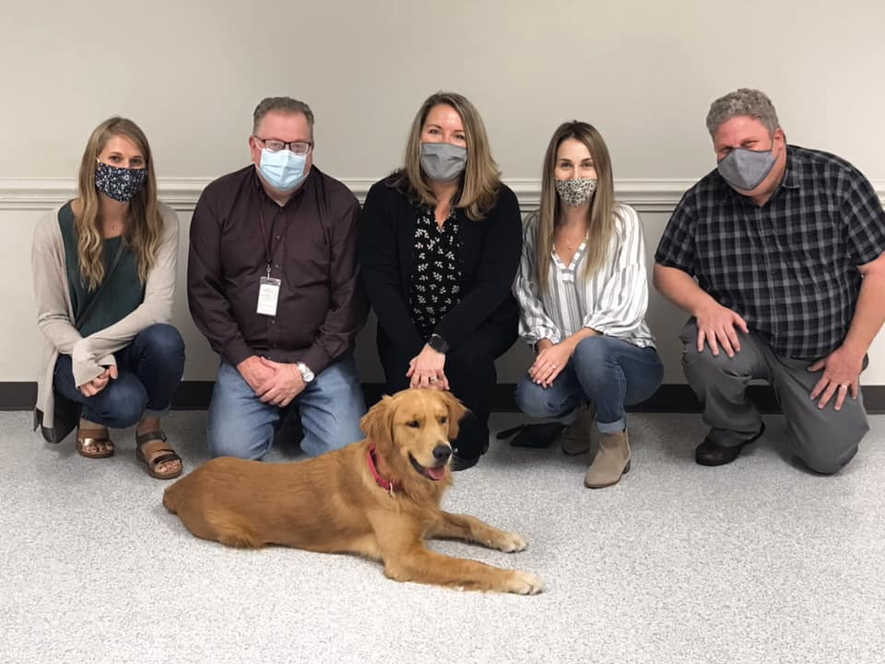

Some EXCITING News from Big Spring School District…

After a long wait, the District added a therapy dog, **Lincoln**, to the Big Spring Family back in 2020! Lincoln was in training through United Disabilities Services (*UDS*), and he is permanently stationed at the Middle School. At all times, he will be accompanied by one of his regular handlers from the Middle School. The Middle School currently has 6 handlers for Lincoln.

In an effort to prepare for Lincoln’s visit we want to make sure there are no students in the classroom who possess a severe allergy or fear of dogs. If you have concerns please reach out to our building principal, Mrs. Clarissa Nace. Our learning process around therapy/service dogs over the last several years has been in collaboration with neighboring school districts who currently have therapy/service animals (*Mechanicsburg and Northern*) to outline our plan to provide for the safe implementation of a service animal program.

There is no need to contact us unless your child has a severe allergy treatment plan or possess a severe fear of dogs.

If you have any additional questions about Lincoln, please feel free to contact your child’s teacher, the school nurse (*Ms. Dianne Doll*), and/or the Middle School principal and primary handler (*Mrs. Clarissa Nace*).